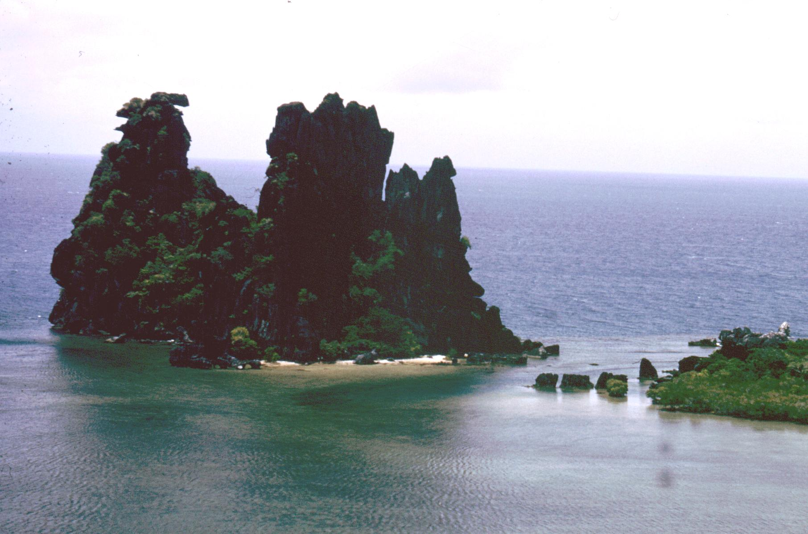
Photo A. Healy
Hienghene, New Caledonia

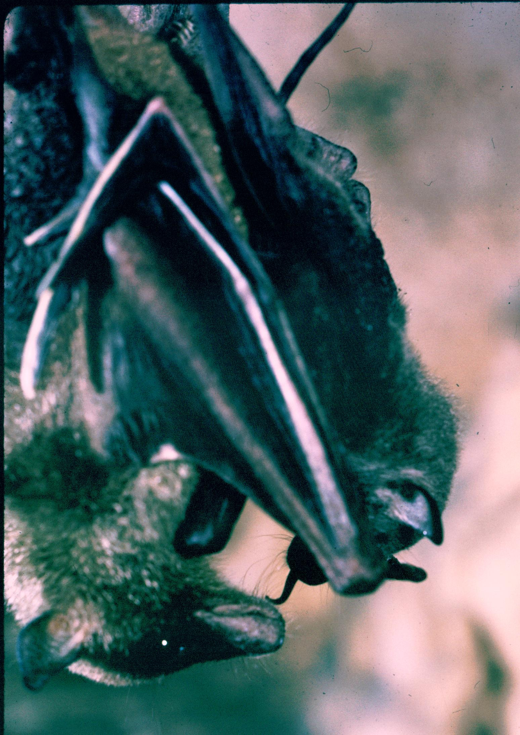
Photo A. Healy

Notopteris neocaledonica : Mother with young.

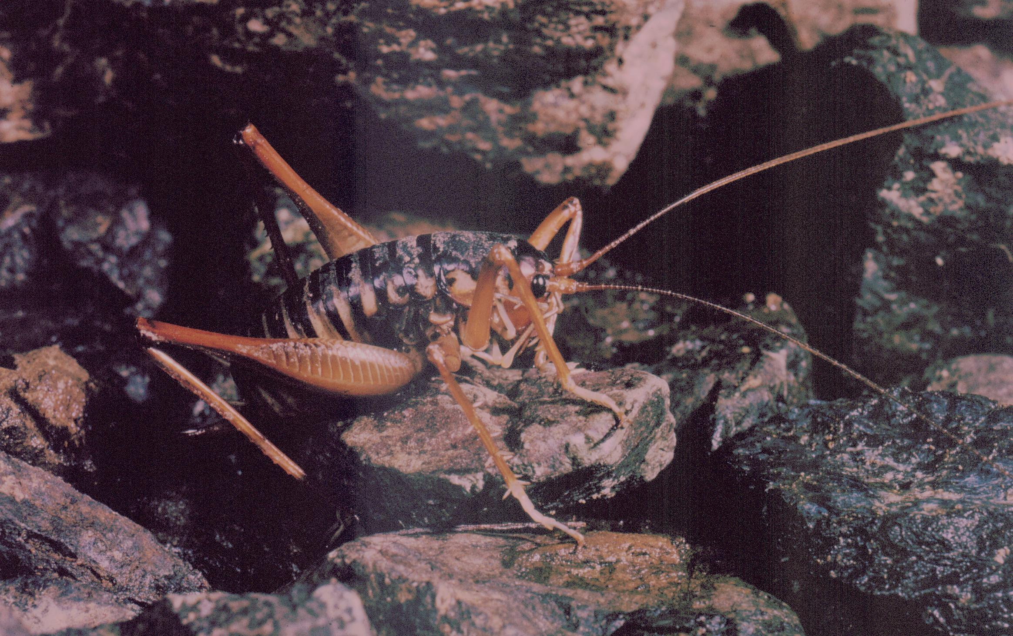
Photo A. Healy
Rhaphidophorid cricket in Grotte d’Adio, Poya, New Caledonia.

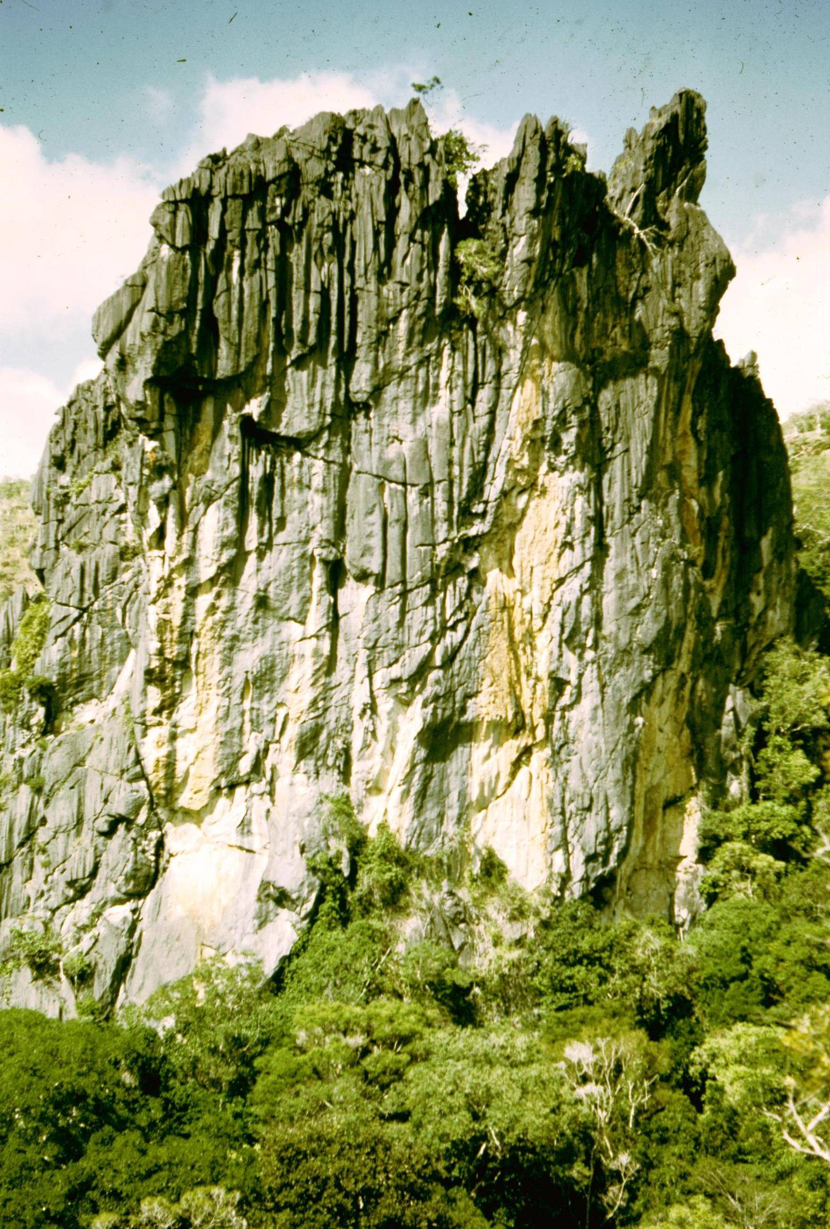
Photo E Hamilton-Smith
Karst Tower near Grotte d’Adio, Poya, New Caledonia

Karst and Caves of the

South Pacific

A state-of-knowledge review

Elery Hamilton-Smith

IUCN / WCPA Task Force on Caves and Karst.

V 1.1
July 2007.

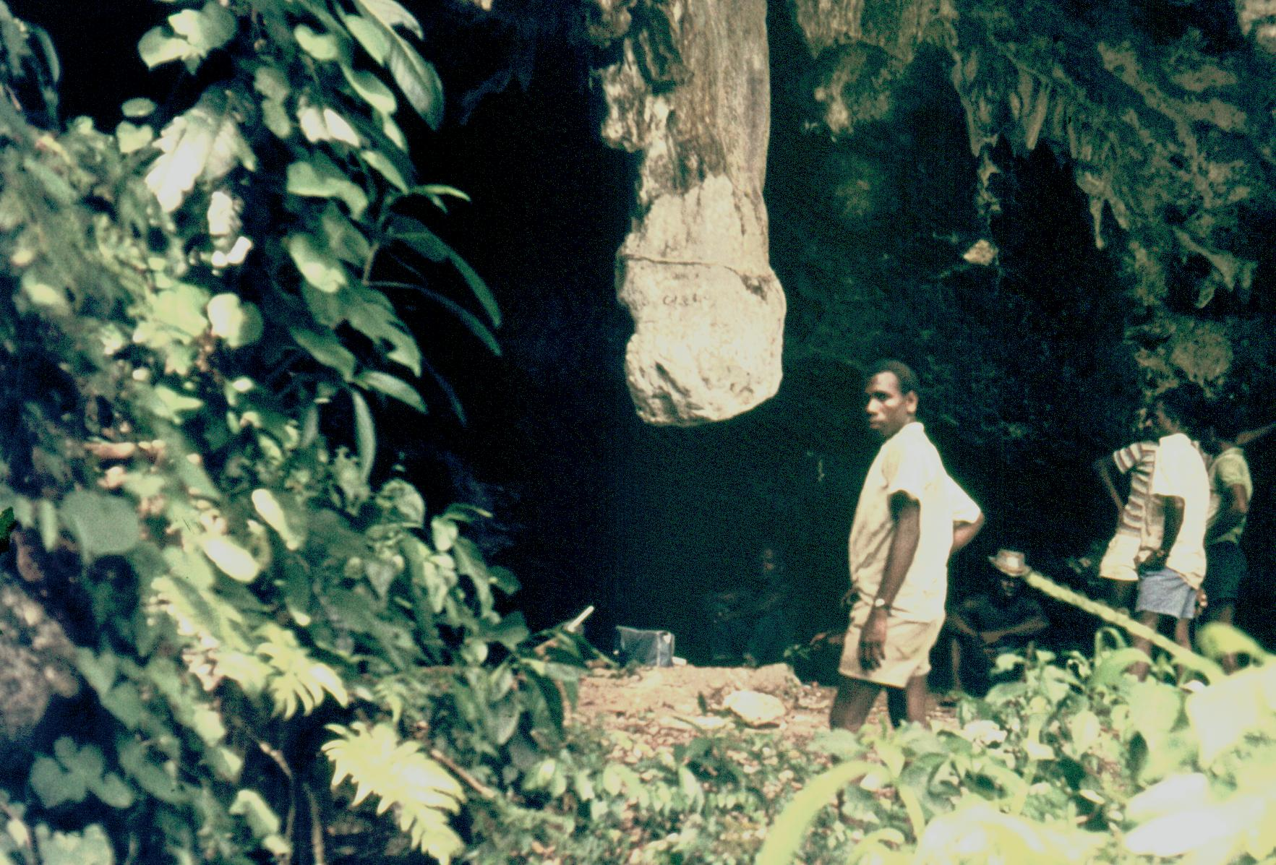
Photo E. Hamilton-Smith
Bat Cave, Aore Island, Vanuatu

